NAME
INSTITUTION NAME
DATE

Explain the cross-communication that occurs between plants and bacteria in the development of root nodules. What does the plant get out of the symbiosis? What does the bacteria get? (15 points)

The cross-communication that occurs between plants and bacteria in the development of root nodules is a symbiotic relationship with nitrogen-fixing soil bacteria called rhizobia. The result of this symbiosis is to form nodules on the plant root, within which the bacteria can convert atmospheric nitrogen into ammonia that can be used by the plant. The plant obtains ammonia and bacteria obtain carbon compounds generated through photosynthesis
Draw how the carbon cycle in the open ocean works and how that carbon can eventually be used to make a fish. Be as explicit as possible. 15 points.

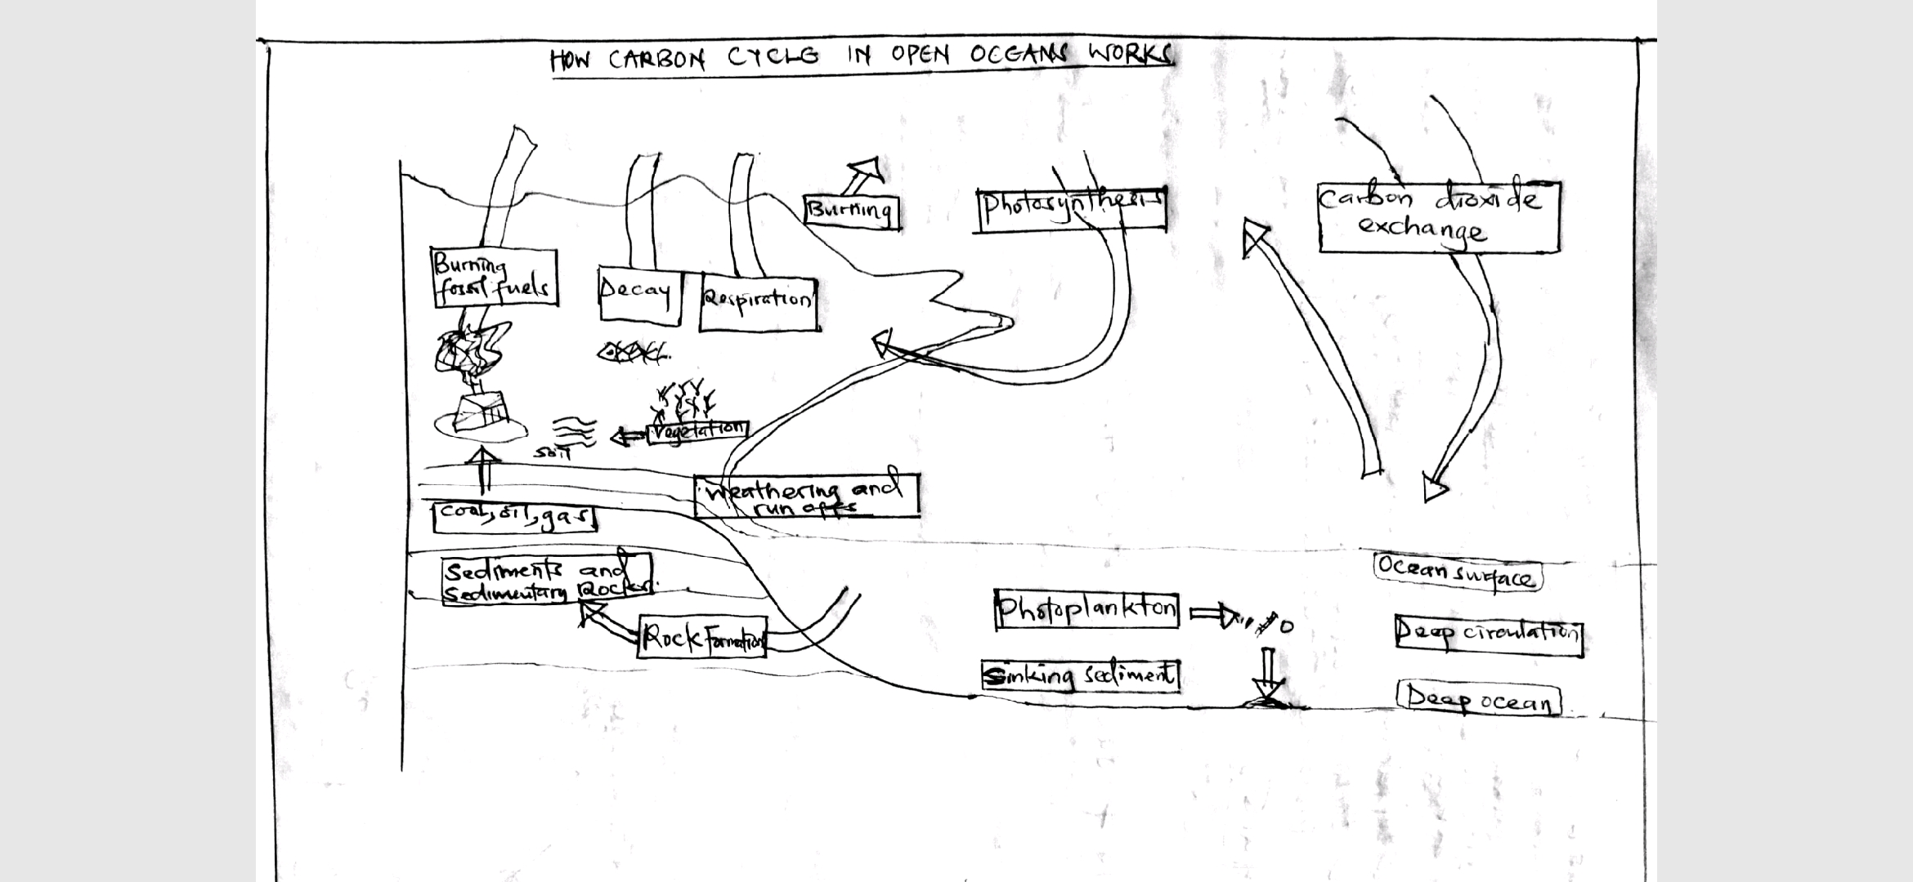The ocean plays an important part in the carbon cycle. Overall, the ocean is called a carbon ‘sink’ because it takes up more carbon from the atmosphere than it gives up. Carbon dioxide from the atmosphere dissolves in the surface waters of the ocean. Some of the carbon dioxide stays as dissolved gas, but much of it gets turned into other things. Photosynthesis by tiny marine plants (phytoplankton) in the sunlit surface waters turns the carbon into organic matter. Many organisms use carbon to make calcium carbonate, a building material of shells and skeletons. Other chemical processes create calcium carbonate in the water. The using up of carbon by biological and chemical processes allows more carbon dioxide to enter the water from the atmosphere.

3A. Explain the rule that governs grazing. (3 pts) The grazers rule is that the optimal prey size increases with the predators size and the large grazers feed from the small grazers in a trophic level.
3B. Why does this rule exist? (3 pts)
This rule exists because there is difference in feeding levels and habits for the grazers.
Explain what “kill the winner” means, what viral life styles are meant in this phrase, and why bacteria can still exist even when viruses are around in the environment. (10pts)
The "Kill the Winner" hypothesis (KTW) is a model of population growth involving prokaryotes, viruses and protozoans that links trophic interactions to biogeochemistry. It is based on the concept of prokaryotes taking one of two reactions to limited resources: "competition", that is, that priority directed to growth of the population, or a "winner"; and "defense", where the resources are directed to survival against attacks. It is then assumed that the better strategy for a phage, or virus which attacks prokaryotes, is to concentrate on the "winner", the most active population (possibly the most abundant). “Killing the winner” hypothesis: Viruses typically attack the most active members/dominant strains in an environment. The viral life style meant in this phase are competition, predation, parasitism and defense life styles. Bacteria have defense against viruses and small mutations can prevent attachment that’s why bacteria can be found around the virus environment.

What is meant when we say a dinoflagellate is mixotrophic? (5 pts)
Mixotrophs, however include a combination of phagotrophic and phototroph. Mixotrophic dinoflagellates are a sub-type of planktonic dinoflagellates and are part of the phylum Dinoflagellata. Dinoflagellates have long whip-like structures called flagella that allow them to move freely throughout the water column.
Explain at least 4 different ways that bacteria can “play defense” versus viruses and grazers in the water column (5 pts)
The defense in bacteria is achieved in the following ways;
Small mutations can prevent attachment. Keeping up resistance can have a fitness cost, making resistant cells grow slower. However, they keep going if the sensitive ones are killed off. In this graph, the insensitive one doesn’t take over entirely because it is a bad competitor for carbon. The sensitive goes up and down and they coexist and that viral attack is numbers game – virus kills host then has to go find another one.
The other methods of defense are through restriction-modification of DNA, Mutation of attachment site and CRISPR – Cas Host Viral Defense.
Compare and contrast Synechococcus and Prochlorococcus, using at least 5 points (8 pts)
The Prochlorococcus are tiny in size while Synechococcus are lager in size.
Prochlorococcus possesses a remarkable pigment complement, which includes divinyl derivatives of chlorophyll a and b which are not observed in Synechococcus.
The cells of Prochlorococcus seem to be able to sustain growth and photosynthesis over an irradiance range extending for more than 3 orders of magnitude which is different in the Synechococcus.
Prochlorococcus typically divides once a day in the subsurface layer of oligotrophic areas, such as the central oceanic gyres, where it dominates the photosynthetic biomass which is different in Synechococcus.
Prochlorococcus have remarkable diversity as compared to Synechococcus.

What growth phase are most microbes typically in in an environment? What might force them into a different growth phase? What is the name for the type of energy they need to have when they aren’t growing? (5 pts)
The log phase is also the stage where bacteria are the most susceptible to the action of disinfectants and common antibiotics that affect protein, DNA, and cell-wall synthesis
The growth of microorganisms in the body, in nature, is greatly influenced by temperature pH, moisture content, available nutrients, and the characteristics of other organisms present.
Why do methanogens and sulfate reducers compete? What exists that can avoid this competition? (10 pts)
Sulfate ions did not inhibit methanogenesis in estuarine sediments supplemented with methanol, trimethylamine, or methionine. However, sulfate greatly retarded methanogenesis when hydrogen or acetate was the substrate. Sulfate reduction was stimulated by acetate, hydrogen, and acetate plus hydrogen, but not by methanol or trimethylamine. This indicate that sulfate-reducing bacteria will outcompete methanogens for hydrogen, acetate, or both, but will not compete with methanogens for compounds like methanol, trimethylamine, or methionine, thereby allowing methanogenesis and sulfate reduction to operate simultaneously within anoxic, sulfate-containing sediments.
In the Carini et al. paper we read, what was discovered that may give us pause when examining microbial diversity in an environment? (10 pts).
In the paper we read it was discovered that the microbes reshaped the oceans and atmosphere and gave rise to conditions conducive to multicellular organisms. Microbes can be roughly classified according to the range of temperature at which they can grow. The growth rates are the highest at the optimum growth temperature for the organism. The lowest temperature at which the organism can survive and replicate is its minimum growth temperature. The highest temperature at which growth can occur is its maximum growth temperature. The following ranges of permissive growth temperatures are approximate only and can vary according to other environmental factors. Constant subzero temperatures and lack of obvious sources of nutrients did not seem to be conditions that would support a thriving ecosystem. To their surprise, the samples retrieved from the lake showed abundant microbial life. In a different but equally harsh setting, bacteria grow at the bottom of the ocean in sea vents, where temperatures are high.
What conditions are needed to fix nitrogen? Name 2 locations where they can be found (2 pts)
Biological nitrogen fixation (BNF) occurs when atmospheric nitrogen is converted to ammonia by an enzyme called nitrogenase. Nitrogenases are enzymes used by some organisms to fix atmospheric nitrogen gas (N₂). Nitrogen fixation occurs in root nodules of plants belonging to the legume family. The root nodules of legumes contain symbiotic bacteria which contain the enzymes needed for nitrogen fixation.

Some microbes need to access iron for their energy – what is this process called and how can a microbe interact in this process with an insoluble piece of iron? (6 pts)
The common iron-oxidizing bacteria, viz., Gallionella, Sphaerotilus, Crenothrix, and Leptothrix species oxidize ferrous ions to ferric state to obtain their energy. They deposit ferric oxide on carbon steel pipeline surfaces and promote tubercle formation. The most common iron-oxidizing bacteria are found in long sheaths and belong to the class Chlamydobacteriales. These long filaments are readily seen under the microscope and have a characteristics pattern. Filamentous iron bacteria are “omnipresent” in carbon steel and iron distribution system pipelines.
What was your favorite topic in this class? (3 pts)
The most interesting topic of this class is the topic about viruses it was fun studying the topic in this class.

